PREP & DIE FILE vs. PREP LIST by MATERIAL REPORT

Question: Why does the report for the Prep File differ from the Preparation by Material Report.

Answer: Simply, they use different files. The E-R-7 report prints the Die# or Plate# that was entered on the SPEC folder of an estimate.

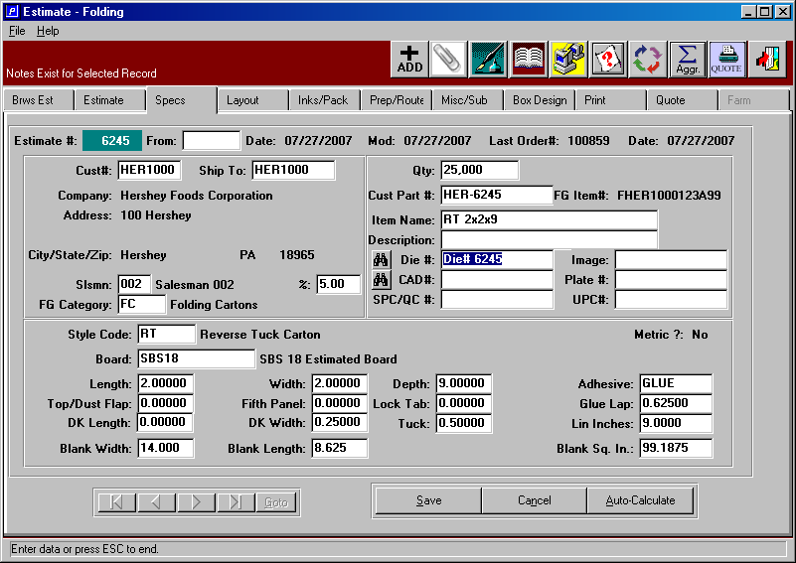

Please note, if the N-K-1 system administration value AddPrep logical value is Yes, when the Die# or Plate# is entered on the Spec folder, the Die# and/or Plate# will prompt to update to E-B-7 file. Hence the E-R-7 and E-B-7 will contain the same data.

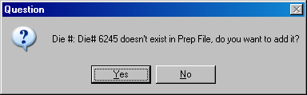

The prep file maintenance added via the menu E-B-7 is a file for costing the die and is entered on the PREP/ROUTE folder of the estimate.

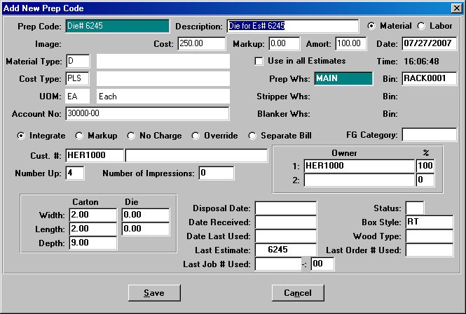

The cost of a plate or die comes from the PREP / ROUTE.
The die# on the Spec folder does not have to match the Prep Route Folder.
For example, the Prep / Route may simply state DIE CHARGE,
whereas the SPEC folder may have a specific DIE# that was never added to the E-B-7 file.

In any event, if I was the data processing manager, I would make any DIE on the SPEC folder automatically create the same code in the E-B-7 file.

Please note, to generate the cost, the Prep Route folder must have the same Die#.
Only then will the E-B-7 file = E-R-7 report.

